##Oil shipping savings OH

##To calculate week by week the savings on oil shipping after the installation of the oil recovery tanks at Ohio the plant

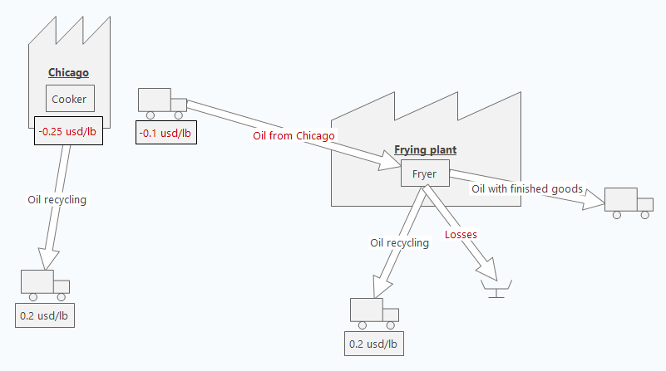

##Data needed:

##Fat consumption file sent by DAVID S,

##weekly pounds produced at Ohio plant

##Oil production (I believe) and shipping (definitely) costs, usd/lb

##setwd as R

oil<-function(){

##0.1 usd/lb is the cost of oil shipped, 0.25usd/lb cost of production, as per David M, March 2018

opc<-0.25

osc<-0.1

##input the necessary data

yp_fg<-read.csv("2 2) Fior all data.csv")

fat<-read.csv("Fat.csv")

##select OH from both files, and the columns of interest

fatoh<-select(fat[grep("OH",as.character(fat$Location),ignore.case=TRUE),],1:11)

fatoh<-transform(fatoh,weekc=as.Date(WeekC, "%m/%d/%Y"))

ypoh<-select(yp_fg[grep("OH",as.character(yp_fg$Location),ignore.case=TRUE),],Location,Date, PS.Total.FG.LBS,PS.Actual.FG.LBS,PS.Fried.Lbs,CR.TT.Fried.Lbs,CR.TT.Finished.Goods.Lbs,TT.Finished.Goods.Lbs.Total,WeekC)

ypoht<-transform(ypoh,date=as.Date(Date,"%d-%b-%y"),weekc=as.Date(WeekC, "%d-%b-%y"))

ypohw<-summarize(group_by(ypoht,Location,weekc),fglb=sum(TT.Finished.Goods.Lbs.Total,na.rm=T),psalb=sum(PS.Actual.FG.LBS,na.rm=T),crlb=sum(CR.TT.Finished.Goods.Lbs,na.rm=T))

##merge both tables into one

foroil<- merge(fatoh,ypohw,by.x="weekc",by.y="weekc",all.x=FALSE,no.dups=TRUE)

bline<-mutate(filter(foroil,weekc<"2018-12-9"),oilshlb=parse_number(Lbs.Oil.Used.FG.Lbs)*fglb)

##bline<-mutate(filter(foroil,weekc<"2018-12-9"),oilshcost=parse_number(Lbs.Oil.Used.FG.Lbs)*fglb*osc)

blinem<-summarize(bline,ref=sum(oilshlb,na.rm=T),totlb=sum(fglb,na.rm=T),base=ref/totlb)

oilshc<- select(mutate(filter(foroil,weekc>="2018-12-9"),oilshcost=parse_number(Lbs.Oil.Used.FG.Lbs)*fglb*osc,oilrefcost=blinem$base*fglb*osc),weekc,Location.x, Lbs.Oil.Used.FG.Lbs,fglb, oilshcost,oilrefcost)

##foroilsav<-cbind(oilshc,blinem$base)

oilshsav<-numeric()

k<-0

for(i in 1:nrow(foroilsav))**{**

oilshsav[i]=as.numeric(k)-as.numeric(oilshc$oilshcost[i])+as.numeric(oilshc$oilrefcost[i])

k<-oilshsav[i]

**}**

oilsav<-data.frame(oilshc$weekc,oilshc$Location.x, oilshc$Lbs.Oil.Used.FG.Lbs, oilshc$fglb, oilshc$oilshcost, oilshc$oilrefcost,oilshsav)

write.csv(oilsav,"oilsav.csv")

**h<-ggplot(data=oilsav, aes(x=oilshc.weekc, y=oilshsav))**

**hi<-h+geom_point()+geom_line(size=1.05,color="blue")+theme_bw()+labs(x="Week commencing",y="Oil shipping savings (usd)",title="Ohio oil shipping savings (usd)")+ theme**(plot.title = element_text(hjust = 0.5))**+geom_vline**(xintercept= as.Date(ymd(today())+(1-wday(ymd(today())))),linetype="dashed")+**scale_y_continuous(**labels = scales::comma_format(accuracy=1),expand=c(0,0),breaks=c(0, oilsav$oilshsav), limits=c(**0, max(**oilsav$oilshsav**)),)** +scale_x_date(limits=c(**max(bline$weekc), max(oilsav$oilshc.weekc)),**breaks= **c(max(bline$weekc),oilsav$oilshc.weekc)**)**+theme(axis.text.x = element_text(face="italic", color="#993333", size=9, angle=0))**+**geom_hline**(aes(yintercept=oilsav$oilshsav),linetype="dashed",color="violet")+theme(axis.line = element_line(colour = "blue"), panel.border = element_blank())+geom_segment(aes(x = **max(bline$weekc)** , y = 0, xend = **min(oilsav$oilshc.weekc)**, yend = oilsav$oilshsav[1]))

print(hi)

}